# 

**ASSIGNMENT-4**

**FULL STACK DEVLOPMENT (MERN STACK)**

NAME : B.Iswarya

EMAIL ID : iswaryabasappagari@gmail.com

Phone :9381093305

ROLL No. :209F1A0506(CSE)

COLLEGE : SRI VENKATESWARA INSTITUTE OF TECHNOLOGY

# Creating a Database Using MongoDB and Mongosh  Database Setup and Collection Creation

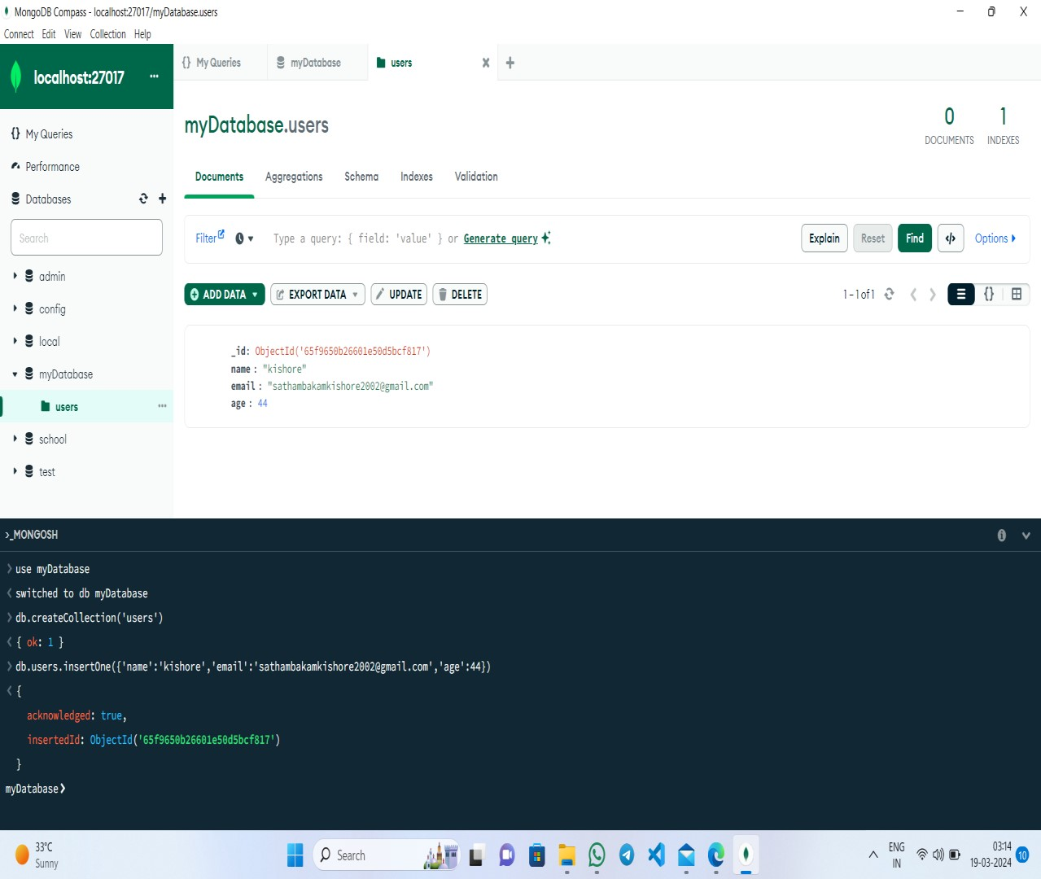

* 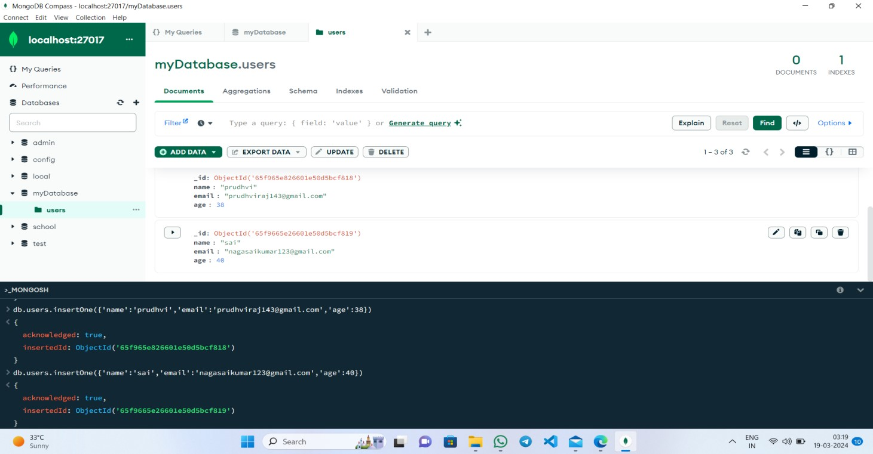**Document Insertion**

❖

**Update Operation**

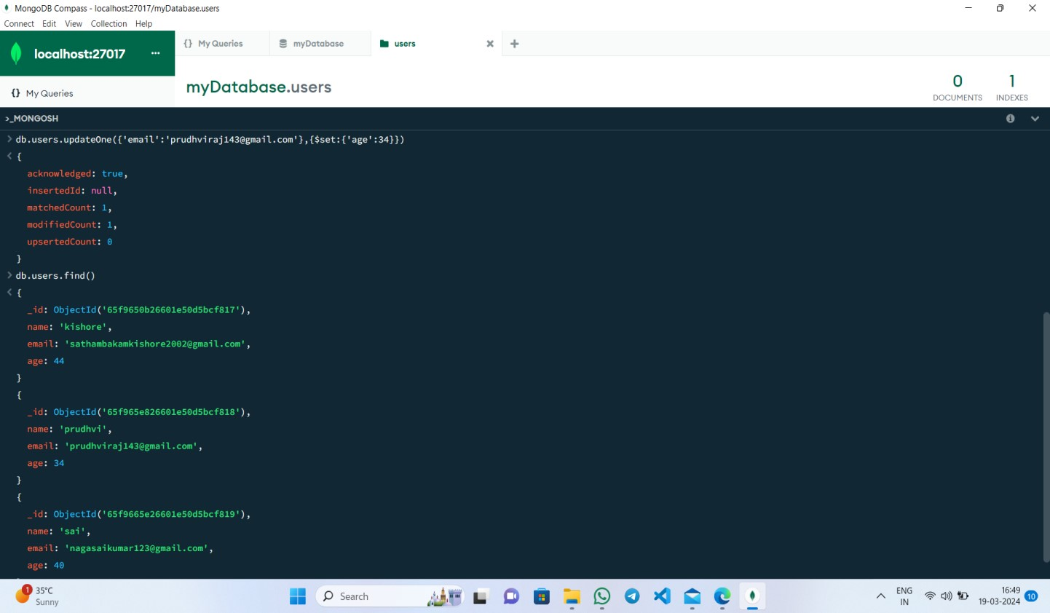

* **Deletion Operation**

